This guide will help you properly cite and reference the various works within the Logos Bible software according to the Modern Language Association (MLA) style.

A. Important Notes – Be Sure to Read
B. Sample Source Citations
C. General Setup and Configuration for Logos 6
D. Acquiring Bibliographic Data for Logos 6
E. Copy and Paste Guidelines

A. IMPORTANT NOTES – BE SURE TO READ

It is important that you be aware of the following in order to cite correctly Logos resources.

1. The automatic footnote function in Logos may not always give you correct MLA source citation information to use in the citation of many resources. This is because Logos cited a number of sources (particularly dictionary articles) by the names of editors of the works rather than by the names of the actual authors of the words being cited. You may need to use the tips found in section D below to find that data.

2. Resources for which the Logos bibliographic data (see section D) lists an editor(s) rather than an author will require you to find the author of the article, essay, or section you are citing as the source.

3. MLA does not use footnotes to cite sources within the body of the text. It uses parenthetical notes. If Logos creates an automatic footnote after you copy and paste text into your document, you will need to delete the footnote and substitute the correct MLA parenthetical note.

4. If, when retrieving the publication data for a resource (see section D), multiple copyrights are listed, choose the one which is preceded by a c.

5. To determine the copyright date for your Logos library, go to the Logos Help menu by clicking on the question mark with circle around it in the upper right hand corner of your Logos desktop. From the menu that appears, select “About Logos Bible Software.” You will find the appropriate copyright date in the box that opens.

6. All bibliographic entries must be double-spaced with a “hanging” indent as evidenced in the examples found in section C. Use only 12 point font.

B. SAMPLE BIBLIOGRAPHY OF WORKS FROM LOGOS BIBLE SOFTWARE
Consult sections D¹ and D² for instructions on how to obtain the bibliographic data you will need for complete and correct citation of a Logos resource.

Note: If the resource does not allow the user to ascertain page numbers from the pagination visual filter (Logos 5 or Logos 6), include in your bibliographic entry the chapter or section title enclosed within quotation marks immediately in front of the book’s title. See the example below citing James Smith’s Major Prophets.

“Amen.” Harper’s Bible Dictionary, Harper and Row, 1985, p. 26, Logos Bible Software, Logos, 2000-2016.
Baly, Denis. “Red Sea.” Harper’s Bible Dictionary, edited by Paul J. Achtemeier, Harpers, 1985, pp. 857-858, Logos Bible Software, Logos, 2000-2016.
Blomberg, Craig L. “The Gospel of Matthew.” Holman Concise Bible Commentary, edited by David S. Dockery, Broadman & Holman Publishers, 1998, Logos Bible Software, Logos, 2000-2016.
Easley, Kendell H. Holman QuickSource Guide to Understanding the Bible. Holman Bible Publishers, 2002, Logos Bible Software, Logos, 2000-2016.
Hoehner, Harold W. “Ephesians.” Bible Knowledge Commentary, edited by John F. Walvoord and Roy B. Zuck, Victor, 1985, Logos Bible Software, Logos, 2000-2016.
The Holy Bible: English Standard Version. Standard Bible Society, 2001, Logos Bible Software, Logos, 2000-2016.
The Holy Bible: New International Version. Zondervan, 1984, Logos Bible Software, Logos, 2000-2016.
Langston, Scott. “Micah, The Book of.” Holman Illustrated Bible Dictionary, edited by Chad Brand, et. al., pp. 1117-1119, Holman Bible Publishers, 2003, Logos Bible Software, Logos, 2000-2016.
Smith, James E. “Political Parables: Ezekiel 17:1-24.” The Major Prophets. College Press, 1992, Logos Bible Software, Logos, 2000-2016.
Smith, Stelman, and Judson Cornwall. “Methuselah.” The Exhaustive Dictionary of Bible Names, p. 173, Bridge-Logos, 1998, Logos Bible Software, Logos, 2000-2016.
Swanson, James. “diakonos.” Dictionary of Biblical Languages with Semantic Domains: Greek (New Testament), Logos, 1997, Logos Bible Software, Logos, 2000-2016.
PARENTHETICAL REFERENCES

All parenthetical references will be recorded in the same format as those for print resources. Use the processes described in “Acquiring Bibliographic Data” to discover available page numbers. For every parenthetical reference, there must be a corresponding bibliographic entry. The parenthetical reference is composed of the following information:

(Author’s last name Page number) Example: (Baly 857)

OR, if the author is not identified …

(“Title of Article” Page number) (“Amen” 3)

Note: If pagination is not available via the pagination visual filter, you should include the section or chapter title in the bibliographic entry in front of the book’s title and then list the author’s name in the parenthetical note.

(Smith)

Citing a Work with an Identified Author
“A major problem concerns the meaning of ‘Red Sea’ in the Exodus story, since we cannot identify the various places mentioned in that account” (Baly 857).
Citing a Work without an Identified Author

“The concept of sacrifice was not foreign to the original New Testament audience as the Old Testament provided a firm contextual foundation for understanding and application” (“Sacrifice” 156-161).
Note that the above example is not a real work, but composed for demonstration.

C. GENERAL SETUP AND CONFIGURATION FOR LOGOS 6

Taking the set-up and configuration steps described below will make correct citation of Logos resources easier.

1. Click on the Tools tab and select “Program Settings” from the menu.

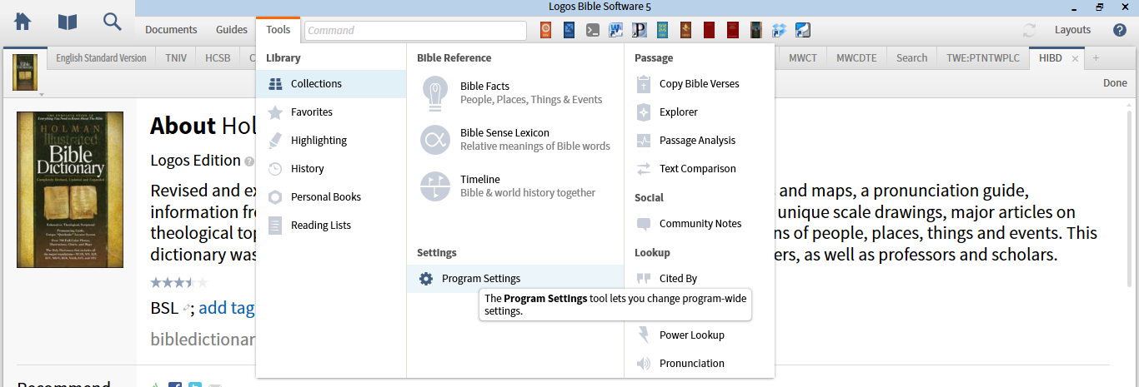

2. In the “General” section of the Program Settings, select “MLA Style” from the drop-down menu for “Citation Style,” and set “Copy Citations” and “Copy Footnotes” to “No.” (The last two steps will prevent much unwanted text from entering your document if you copy and paste from a resource.)

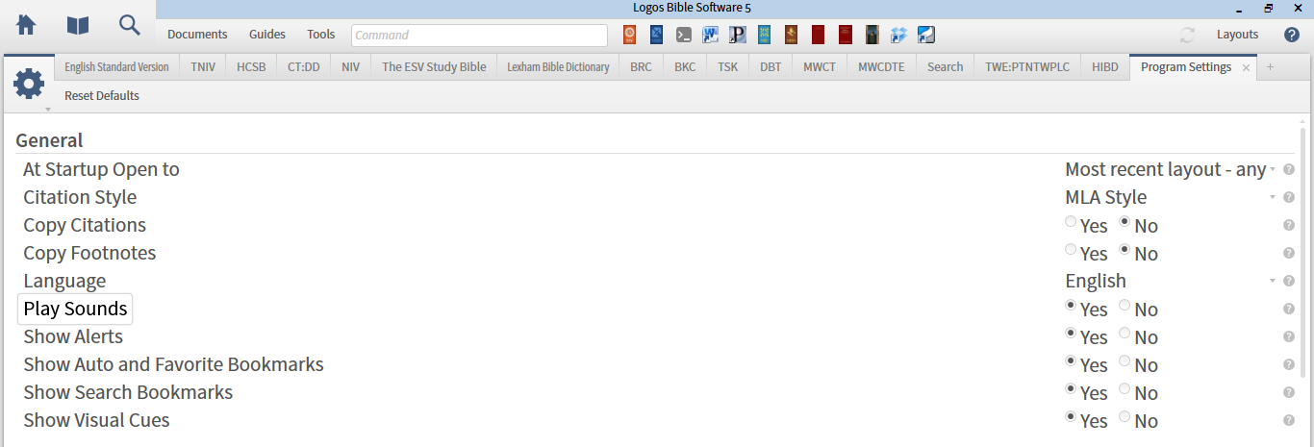

3. Each bibliographic entry requires you list the copyright date for the individual resource you are citing and for the total Logos package you are accessing. To determine the copyright date you should use for the Logos software at the end of bibliographic entries (see sample entries above), go to the Logos Help menu (question mark in the circle in the upper right hand corner of your Logos desktop) and select “About Logos Software.” Use the copyright date you find there.

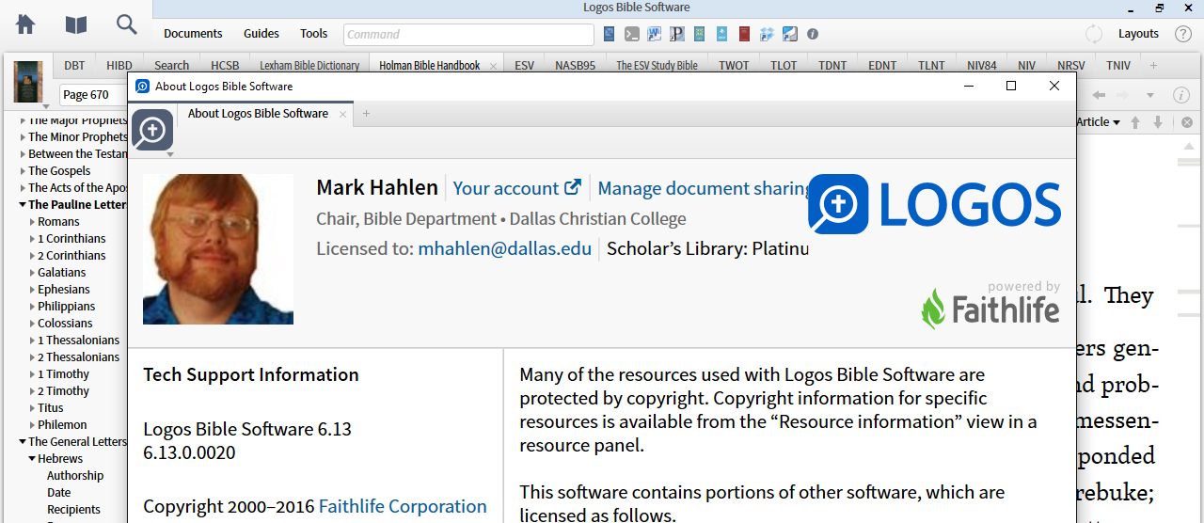

D. ACQUIRING BIBLIOGRAPHIC INFORMATION IN LOGOS 6

This example uses the “Pilate, Pontius” article from Holman Illustrated Bible Dictionary.

Open the desired work (Holman Illustrated Bible Dictionary) and navigate to the desired article/entry (“Pilate, Pontius”). When you are finished recording information from the article, perform the following steps to gather data to help you properly cite the reference according to MLA style.

1. With the work open, click on the Resource Information symbol (circled i) in the upper right hand corner of the resource’s panel.

2. A new window will appear displaying information about the resource you are currently using (Holman Illustrated Bible Dictionary). Scroll down until you find “Article Citation.” Copy and paste into your document. Important: You may not be done yet. First, make sure the font of your pasted text and formatting matches the rest of your document. Second, you may need to rearrange information as Logos may not always get the bibliographic entry entirely correct.
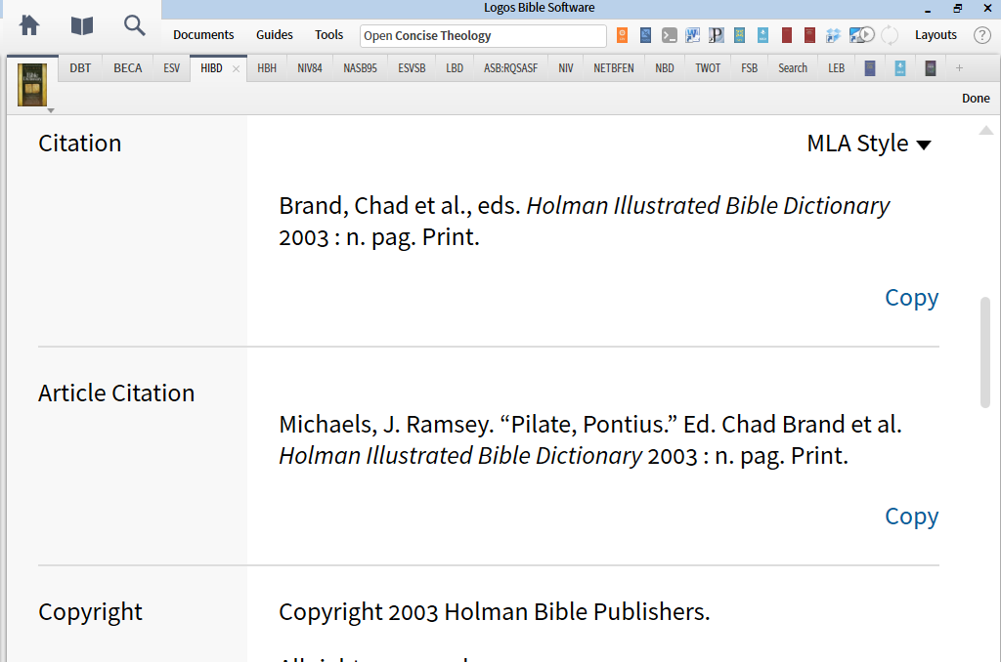

4. Parenthetical notes use page numbers when they are available. To find the page numbers of the original print source, look in the “reference box” located in the upper left hand corner of the resource panel just to the right of the picture of the book cover. Click on the “Show Visual Filters” icon (three dots in a pyramid) to see whether “Show page numbers” is an option. If it is, check on the box.

5. Then, click on the Reference box to see the page number.

6. One may also set the Visual Filters so that the page number will appear inside the panel. If the page number does not appear in the reference box and “Show Page Numbers” is not an available visual filter, then page numbers are not available, and you will simply cite the author’s name in the parenthetical note.

SPECIAL NOTE REGARDING CITATION OF BIBLICAL KNOWLEDGE COMMENTARY, HOLMAN CONCISE BIBLE COMMENTARY, AND LIKE SOURCES

The Bible Knowledge Commentary (Logos 6) and the Holman Concise Bible Commentary are edited collections of many authors’ work. The BKC was edited by John F. Walvoord and Roy B. Zuck and the HCBC by David Dockery. Because Walvoord and Zuck and Dockery are editors, not authors, you should not cite commentary discussion from BKC or HCBC under their names. You must give credit to the author of the comments on the particular biblical book. To find the correct author’s name, open the source’s Table of Contents and look for a section entitles “Contributors” or the like. Scan through this list to discover who wrote the particular section you are reading. Other Logos sources are edited works, and you will need to find such a list to determine who wrote the specific author for a particular work.

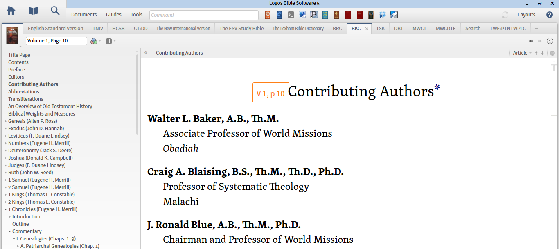

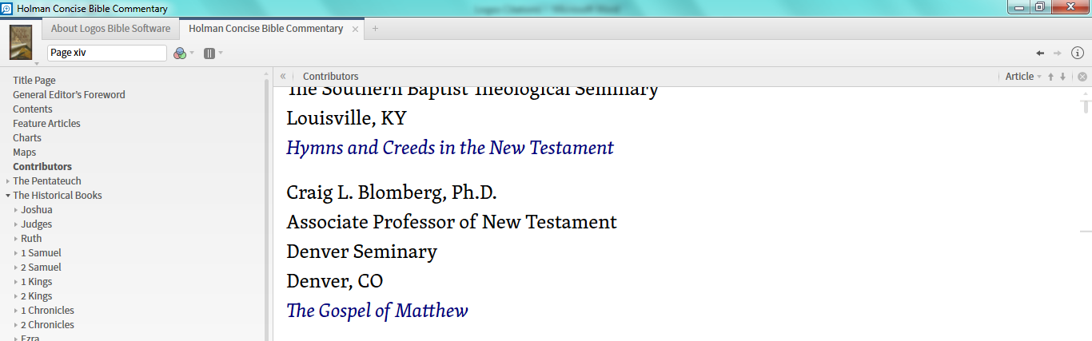
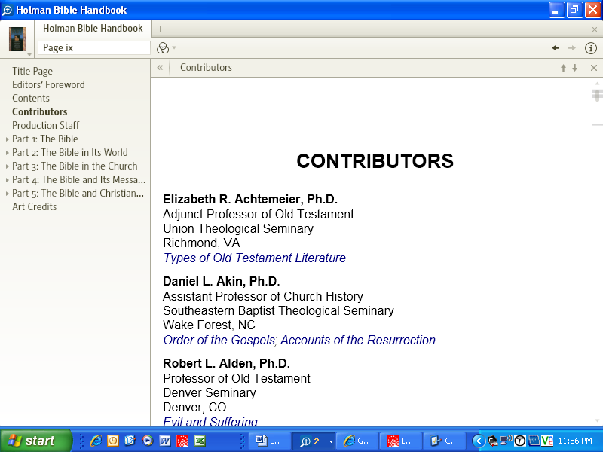
Sample Parenthetical Note
(Hoehner 2:613)

E. COPY AND PASTE GUIDELINES

You may want to copy and paste certain sections of text from Logos Bible Software into your work for purposes of quotation or summarization. The copy and paste functions of Logos are identical to any other computer application.

According to the default settings, when you copy and paste into a word processing document, the software automatically adds footnotes with bibliographic information. Because MLA style uses parenthetical references (as described above), these footnotes are unnecessary and incorrect and should be deleted after pasting. You can avoid the need to do this deleting by turning off the “Copy Citations” function. Instructions for doing so appear above in section C.

