Another Option for Pulling the Data from Moodle
This option only tells you if a student posted or not. It does not indicate if the post was substantive. The advantage of this procedure is that it makes it much easier to notify students that they were marked absent.

- Open your course site
- Scroll down under the “Administration” block until you see “Reports”
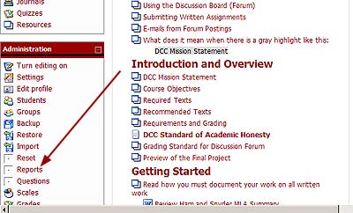
- You will see a screen that allows you to select the log files you want to access. You need to go to the gray-outlined section at the bottom of the screen.
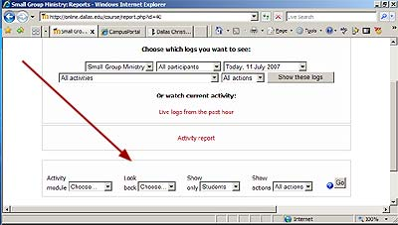
- Click on the dropdown arrows to enter the settings according to your situation.
  - Activity: This will always be set to “Forum”
  - Look: This should be set to 1 week—assuming you check attendance the last day of the week. If you go beyond the last day of the week, you may need to kick it up to “2 weeks.”
  - Show (1): This will always be set to “Students.”
  - Show (2): This will always be set to “Post.”

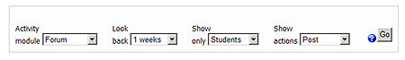
- Click the “Go” button
- This will present you with a screen that contains the setting you just entered, but it asks for one more setting. Click on the dropdown arrow and select the discussion forum for the week you are taking attendance.
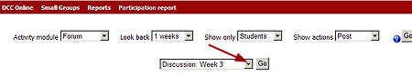
- Click the gray “Go” button
- This presents a table with the information you need. Students who have not posted have “No” in the “Post” column. Students who have posted have a “Yes” and the number of posts.
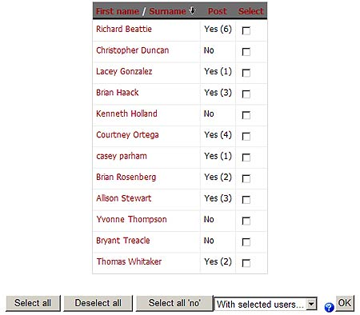
- You will need to know which students had “No” in order to mark them absent that week. (Note in defense of the students: This report was pulled in the middle of a class week to be certain there were students who had not posted. The students you see listed might have posted later.)
- Now Moodle makes it easy to notify the students. Start by clicking the gray button that says, “Select all ‘no’.” This will put a checkmark beside everyone who did not post.
- Now click on the dropdown arrow beside “With selected users” to get the choice to “Add/send message.”
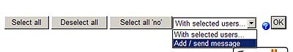
- Send them the message noted above.

