Recording Modes of Attendance in Flex Classes
In an attempt to improve our understanding of the effectiveness of our Flex class offerings, we are asking instructors to record the mode in which all of their students choose to attend from week to week. The process is simple and can be found below.
- You will be using the following definitions of attendance:
  - “Recording”—Use this for asynchronous students who view the class recording and then post in the required participation forum
  - “Live Web Conference”—Use this for students who attend remotely “live” via WebEx conference at the time of class
  - “Face-to-face” ”—Use this for students who physically attend the class session
  - “No grade”—Default setting. Do not use.
- When taking attendance at the beginning of each class session, make note of which students are attending face-to-face and which ones are attending via live web conference. You will indicate this mode of attendance as described in the next step.
- In the “After Class” section of each week in your Flex class, you will see this activity:
Click on the title to enter the activity.
- Click on the link in the upper right-hand corner of the page which says “No attempts have been made on this assignment” to bring you to the page where you will start assigning grades to your students (just as you would when you grade any other journal entry or essay questions).
- IMPORTANT: At the bottom of your list of students, there is a check-box to “Allow quick grading.” If unchecked (which it should be), go ahead and check the box then click on “Save preferences” directly below the quick grading box.
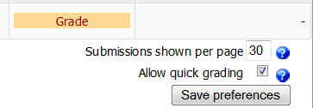
  - Note: Doing this will affect all other assignments in your class site. This option is not usually optimal for the grading of other assignments and should be unchecked as soon as you are finished with this process.
- After clicking “Save preferences,” students will now have a drop-down box to the right of their names. This drop-down will contain the four options explained in step 1 above.
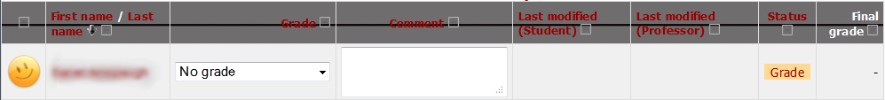
- Go down the list of students and assign a mode of attendance to each using the drop-down menus. You do not need to save after each one, and no comments are necessary.
- Students not present in the classroom or the web conference should be marked as “Recording” by default.
- Once all grades have been assigned, click on the “Save all my feedback” button at the bottom of the list of students.
  - Note: This is a hidden activity, and as such students will not be notified when a new grade has been submitted here as they would with other graded assignments, even though the “Send notification emails” box is checked. Do not uncheck this box, as doing so will affect all other assignments throughout the class site.
- Once feedback has been saved, uncheck the “Allow quick grading” box at the bottom of the page and then click “Save preferences.”

