Dear Instructors,

With the new version of Moodle there will be some adjustments to how a couple things work. First of all discussion forums will be different. We hope that these changes will be easier for you in the end. We apologize for the change and hope that you can adjust with us.

There will no longer be a composite forum grade where you enter the grade for the week’s post. J yea…

Grading the Posts

When reading posts you will need to give each post a percentage grade. You can still use the stair step rubric (100, 93, 85, etc) or you could be more specific. If a post is not worthy of a grade, click on the edit link as shown:
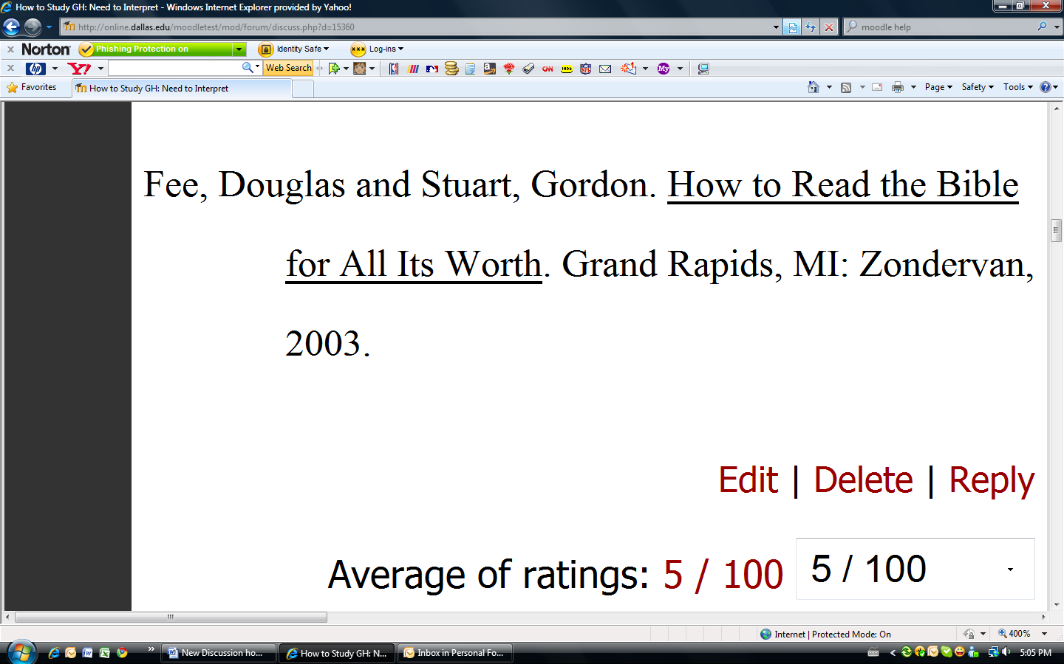

Your name will automatically be at the bottom of the edit window. Place the cursor in front of your name and simply type “READ.” Do not add any further comment. This tells the student you have read the post, but it was not substantive enough to assign a grade.
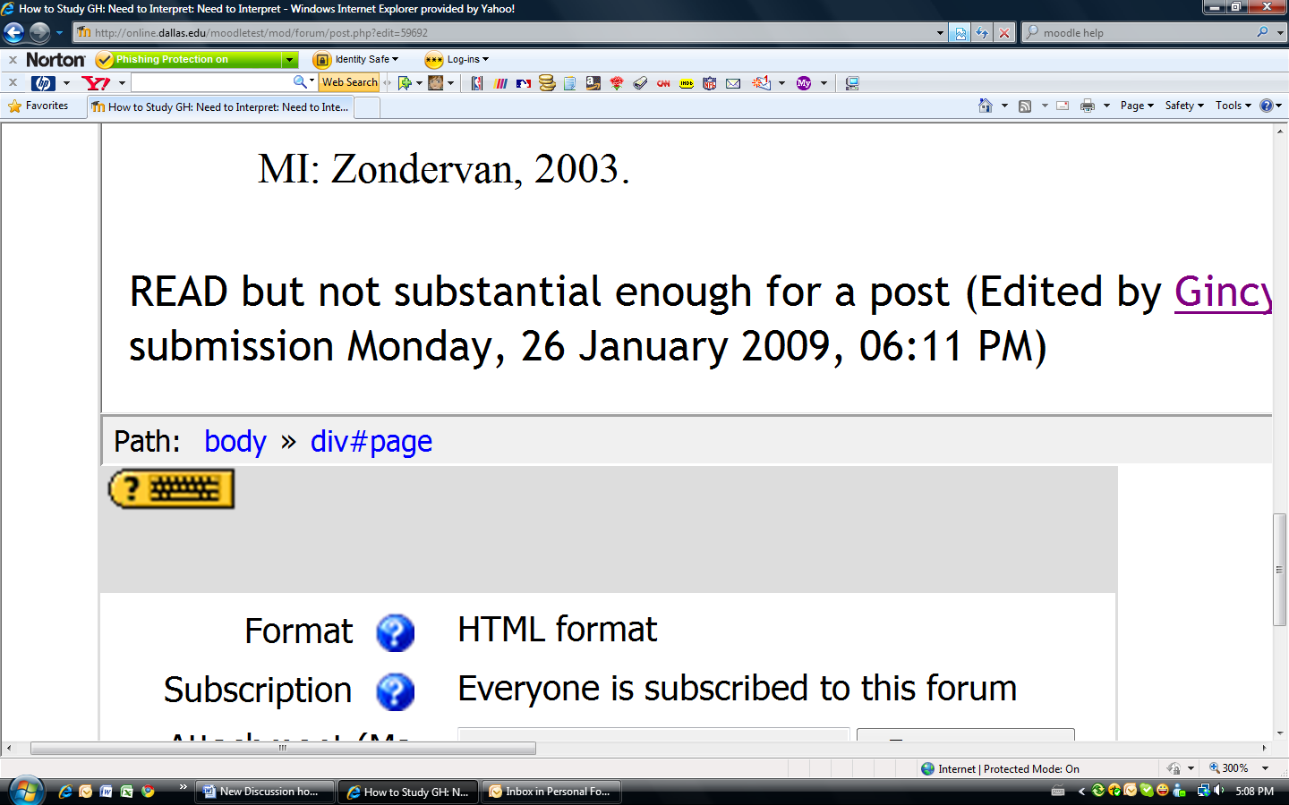

Then leave the grade blank so that it isn’t counted.

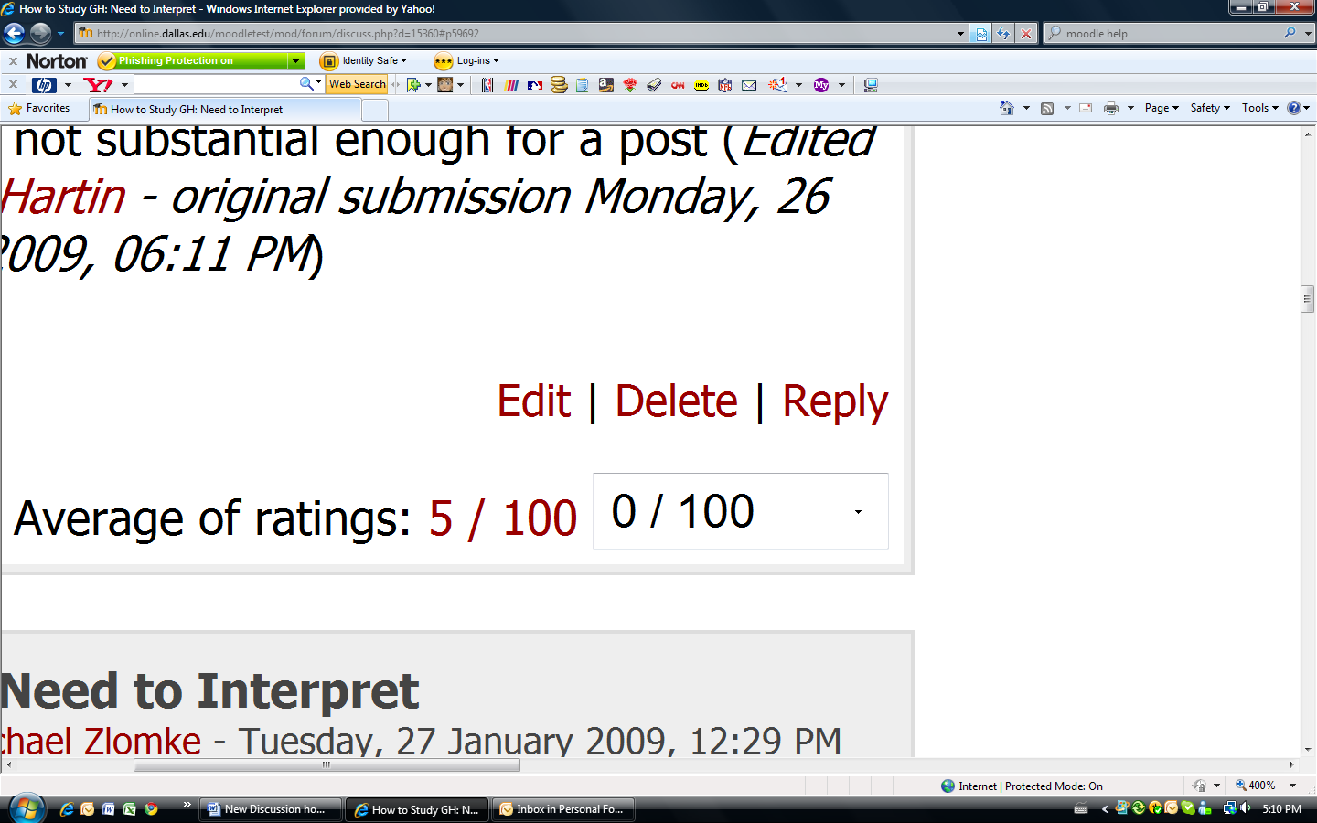

Averaging the Weekly Forum Grade

All forums will be set up at the beginning of the course to count the number of posts. They are also set with a scale of 0-100%.

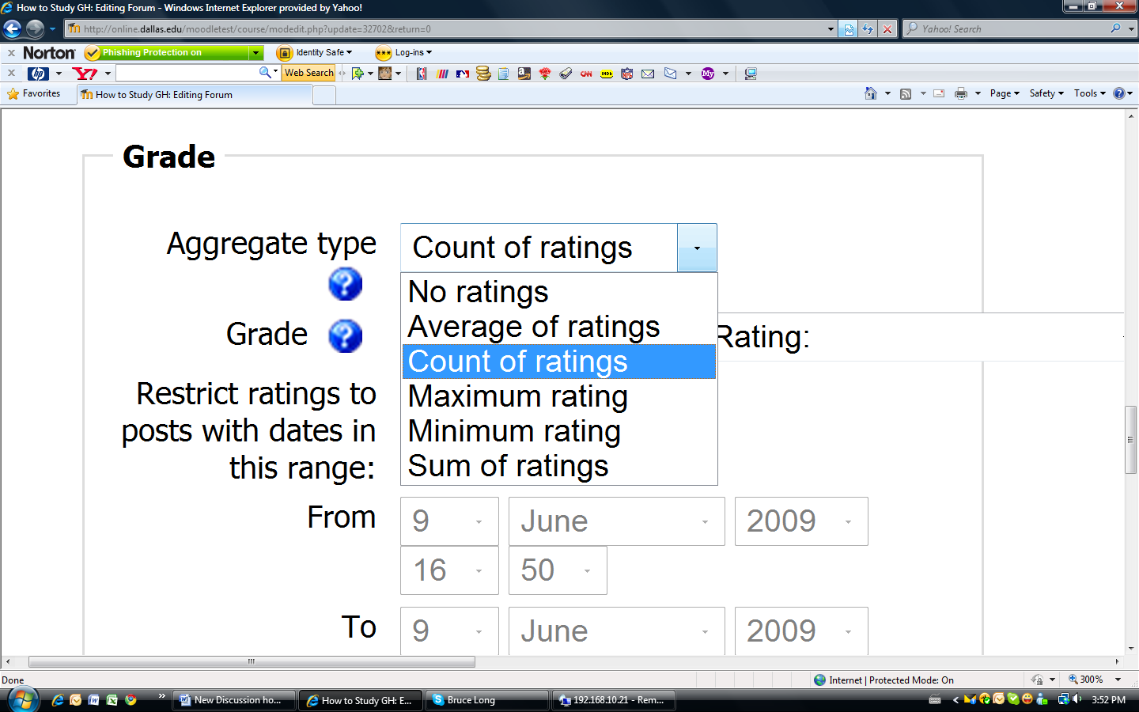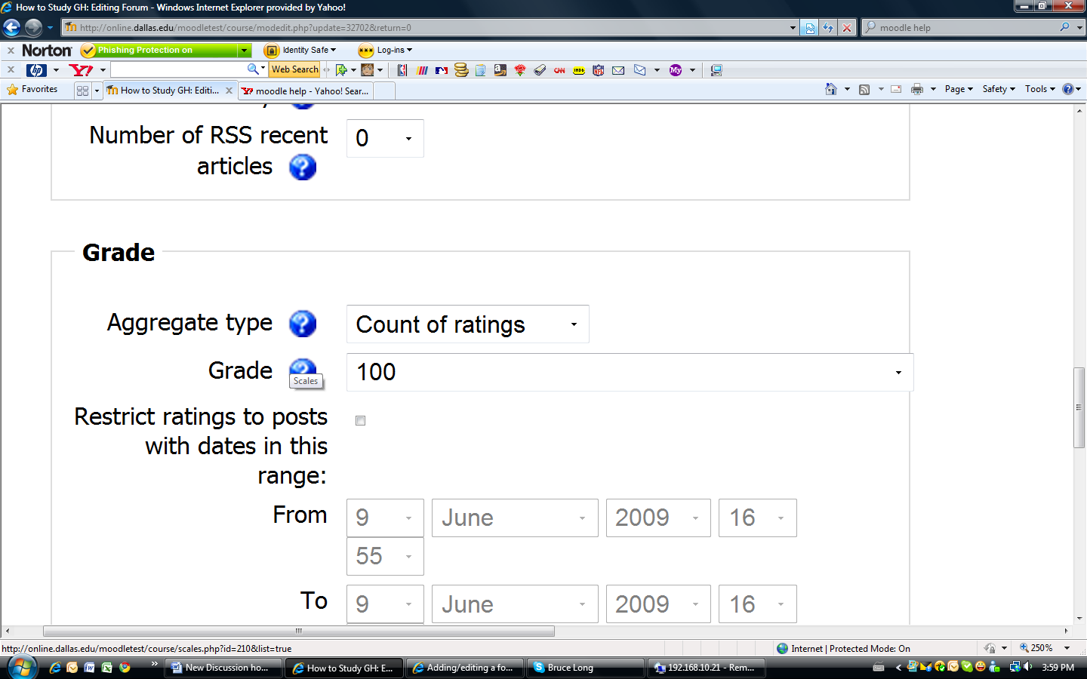

At the end of each week, go to the gradebook

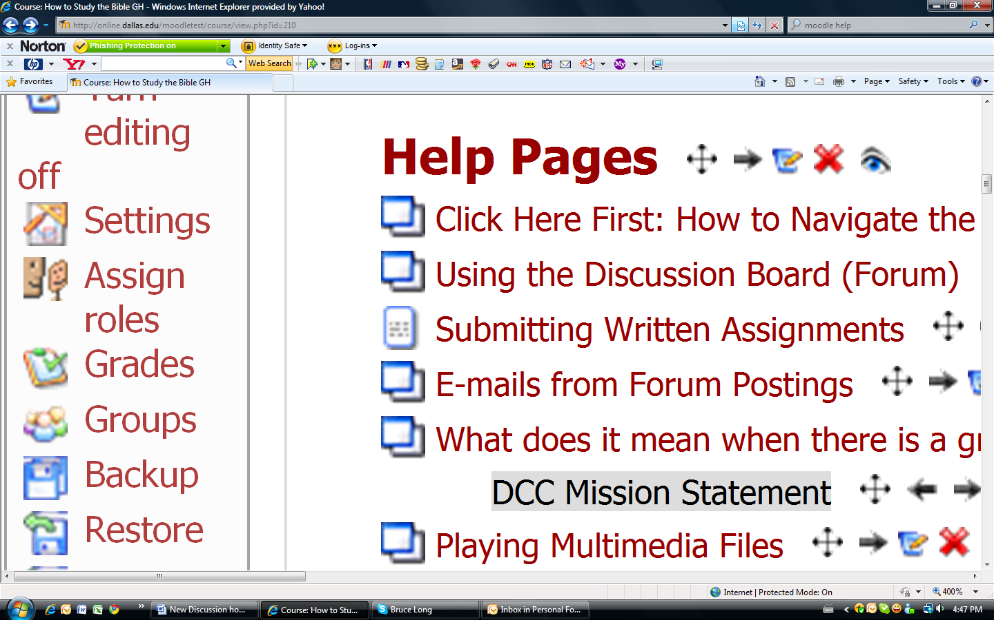

A grade table will open, use the scrollbar to move to the right until you see the discussion column that you are finalizing.
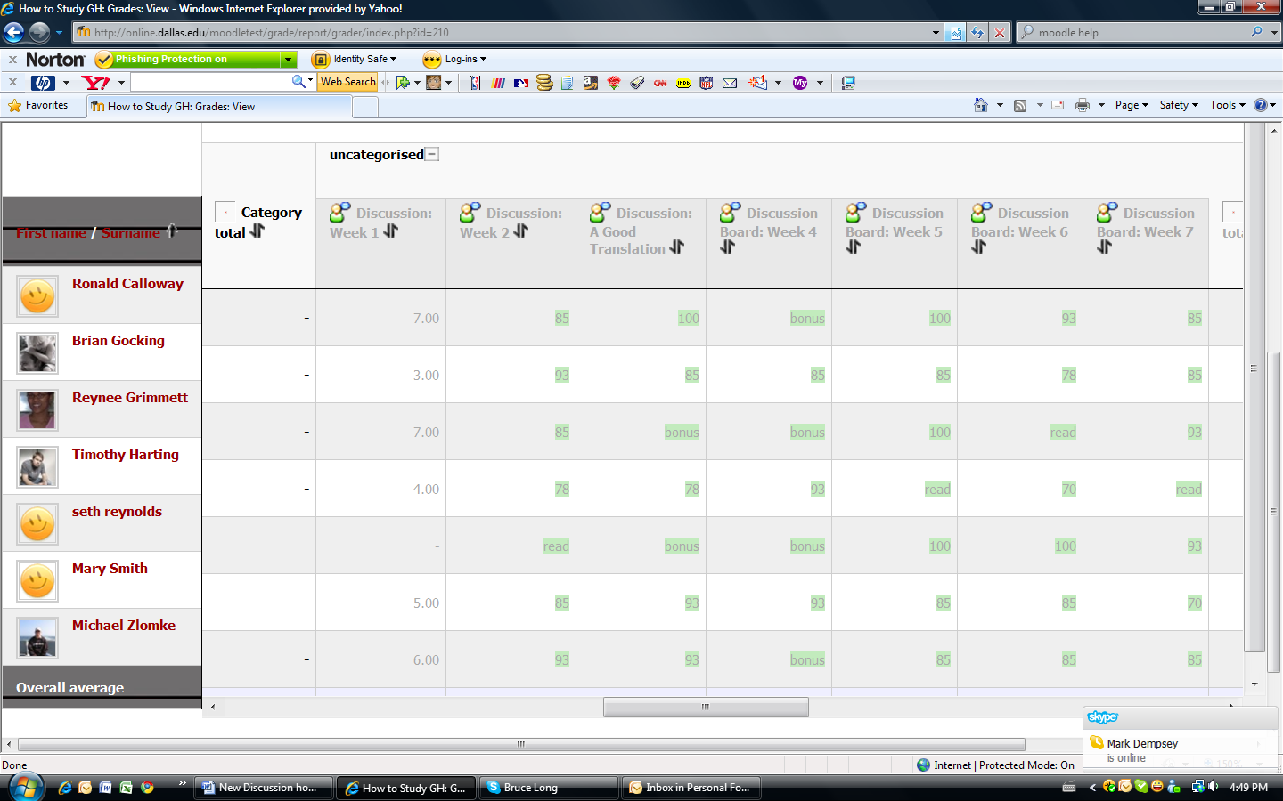

In the column will be a smaller number the grades, showing the number of posts by each student for the specific discussion question. Note any student who does not have the required number of posts for two reasons.
- To change grade accordingly
- To mark attendance accordingly

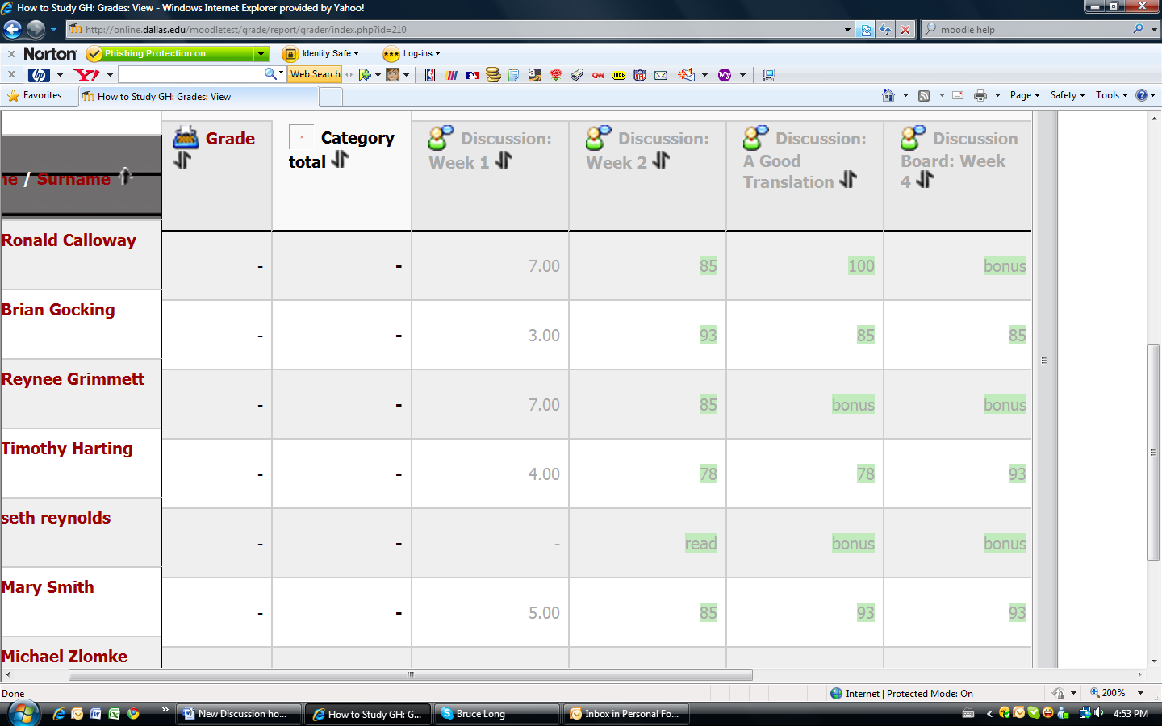

(Reminder: Be sure to go to http://faculty.portal.edu and mark attendance for this week.)

Then you go back to that week’s forum. (Note: You can also get their by clicking the forum name at the top of the grade column in the gradebook.)

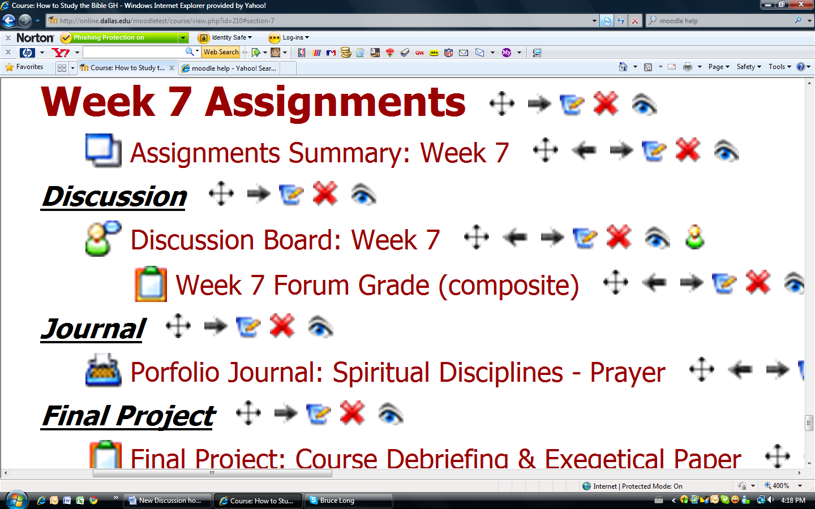

Click on update this forum
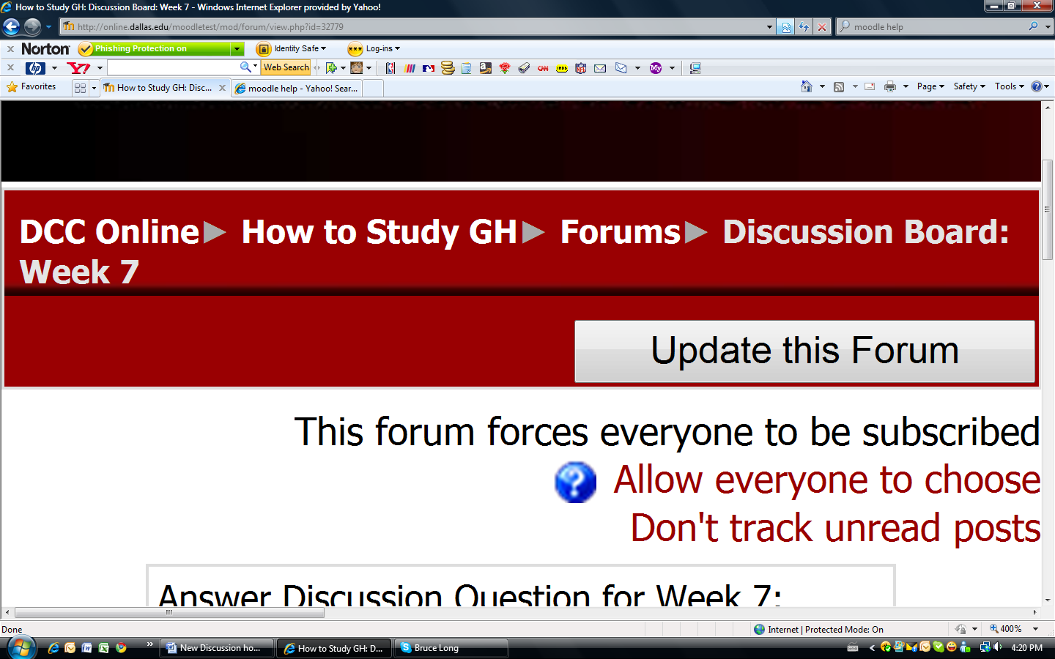

You need to change the type of rating to average.
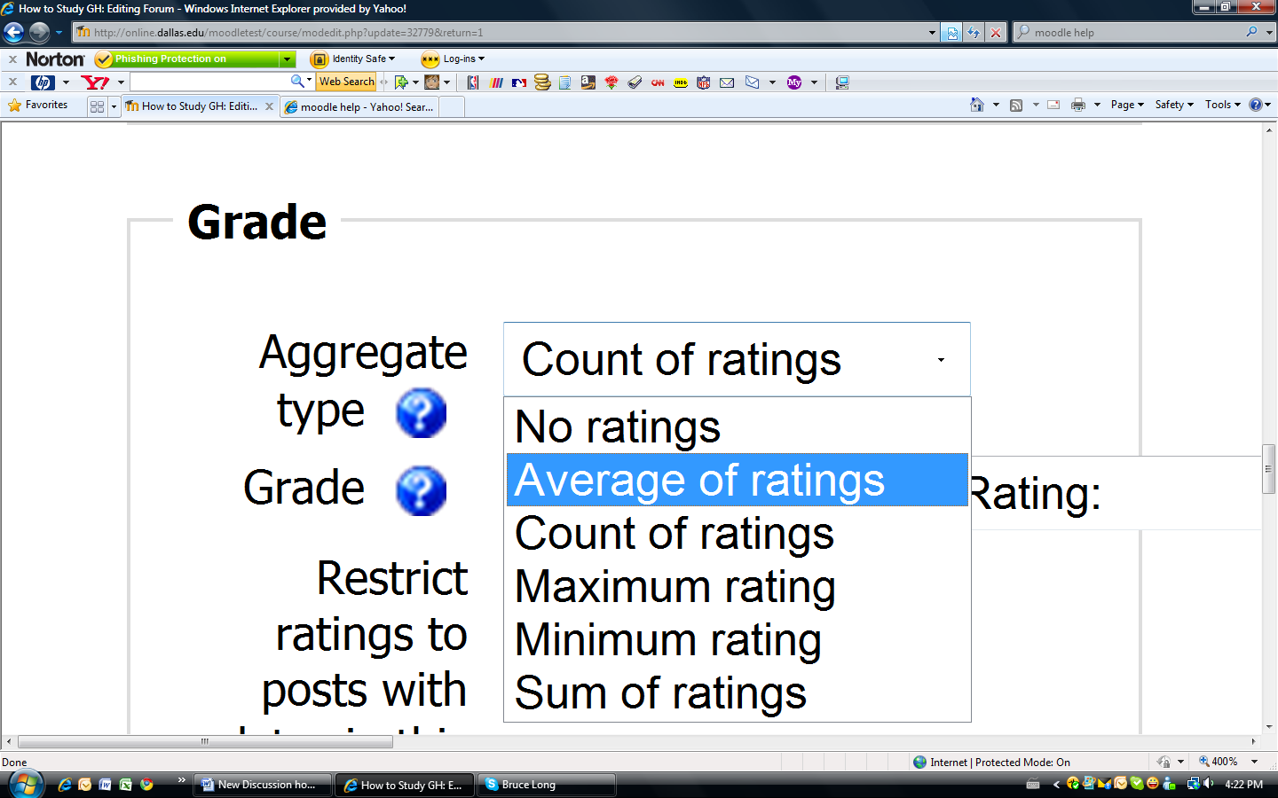

This will automatically mark the grade for the students’ posts that you have graded. If there are any students who did not have the minimum number of posts, you will need to go back into the grade book and manually change their grade.

Once you are back in the gradebook, turn editing on.

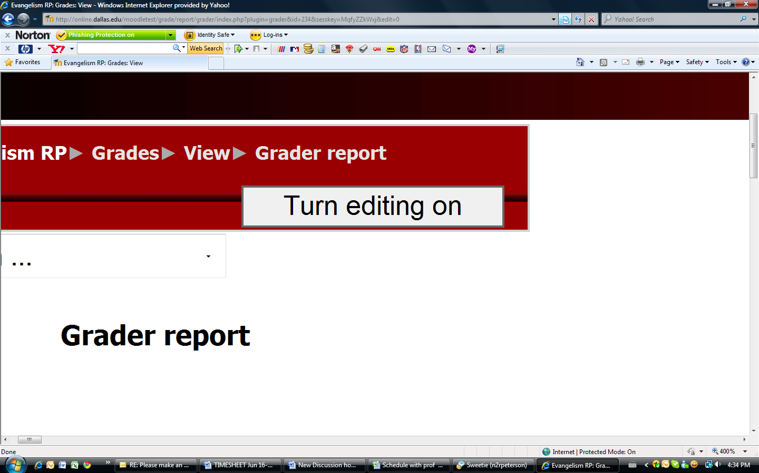

Select the grade you want to change and update it.

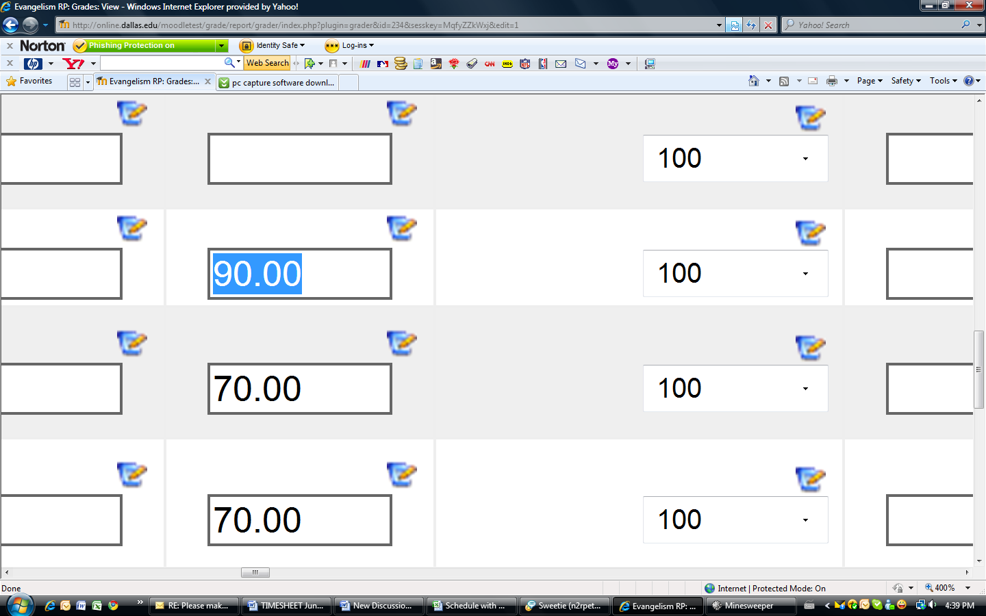

Click UPDATE when done.


