Johari Window Exercise
JOHARI WINDOW OVERVIEW

The Johari Window, named for its inventors, Joseph Luft and Harry Ingham, is one of the most useful models for describing the creation of trust in human interaction.

A four-paned “window” divides personal awareness into four types: open, hidden, blind and unknown. The lines dividing these four panes are like window shades – they can move as an interaction progresses. We build trust by opening our personal shades to others so that we become an open window.

Overview: This lesson is designed to provide a look into how you view your-self and how others view you. It is also provides a way to open the lines of communication with others.

Exercise
Your assignment is to create a JOHARI window representing yourself to the class. This window should consist of information you obtained from various sources; including the results obtained form completing the online Johari assessment located on http://kevan.org/johari.cgi. You will then create a presentation based on what you learn from the assignment. Your presentation should last between 3-5 minutes and consists of a visual you create to represent your window. During the presentation you are to discuss the information contained within each quadrant demonstrating how it relates to how you see yourself and how others see you. Include in your presentation what these descriptors reflect about your helping skills and interpersonal ability from a Christian perspective.
The assignment consists of these major parts.
1. Complete the online assessments as discussed in class (http://kevan.org/johari.cgi). Take the assessment and print out the results.
2. You are to ask 2 members of the class, as well as 3 people not in the class to complete the assessment about you. After completing the assessment yourself, you will be given a link for others to complete for you. Ask them to print the results and give them to you. You will only need to turn in the final results summary after the final person completes the assessment. Record these results.
3. Do some self-exploration, how do you describe yourself? What kind of things do you freely self disclose to people you meet (Open Quadrant), and what things do you usually keep to yourself-not deep dark secrets, but things that you don't jump out and tell people when you first meet them (Hidden Quadrant). What areas does this suggest God is wanting you to continue to develop?
4. Finally, what are your goals for the future? What are you striving to accomplish that you have yet to accomplish? This information is directly relevant to your Unknown Quadrant.
5. Once you have gathered this information you then need to construct your window. Create a visual (see below) representing the four quadrants (Open, Blind, Hidden and Unknown) and creatively place the above information in its appropriate quadrant. Build a window that reflects who you are and how you see yourself.
Don’t forget the brief outline showing each quadrant and listing the pieces of information to be discussed under each!
Prepare a written summary, including an overview of the purpose of a Johari window and a brief review of your results. Be sure to include a personal analysis of both your strengths and growth opportunities. Comment on what God is showing you about yourself, the skills you have and those you need to develop. Also include what it was like to participate in creating your classmates Johari windows. Were you able to be honest and forthright in your assessment of your classmates. Did you experience any anxiety during the process (being assessed or assessing others?
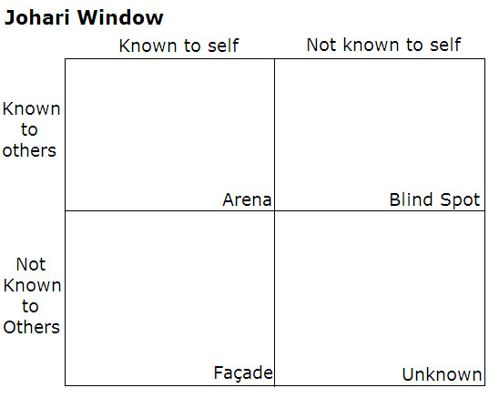

Johari adjectives

able  accepting  adaptable  bold  brave  calm  caring  cheerful  clever  complex  confident | dependable  dignified  energetic  extroverted  friendly  giving  happy  helpful  idealistic  independent  ingenious | intelligent  introverted  kind  knowledgeable  logical  loving  mature  modest  nervous  observant  organized | patient  powerful  proud  quiet  reflective  relaxed  religious  responsive  searching  self-assertive  self-conscious | sensible  sentimental  shy  silly  spontaneous  sympathetic  tense  trustworthy  warm  wise  witty

