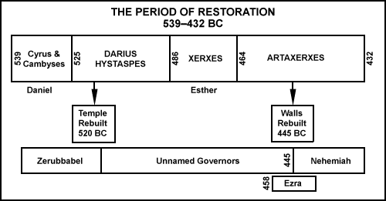

From James E. Smith, The Books of History. Old Testament Survey Series. Joplin, MO: College Press, 1995. Logos Bible Software. Bellingham, WA: Logos. 2002-2010. Software.

